Menu Screen

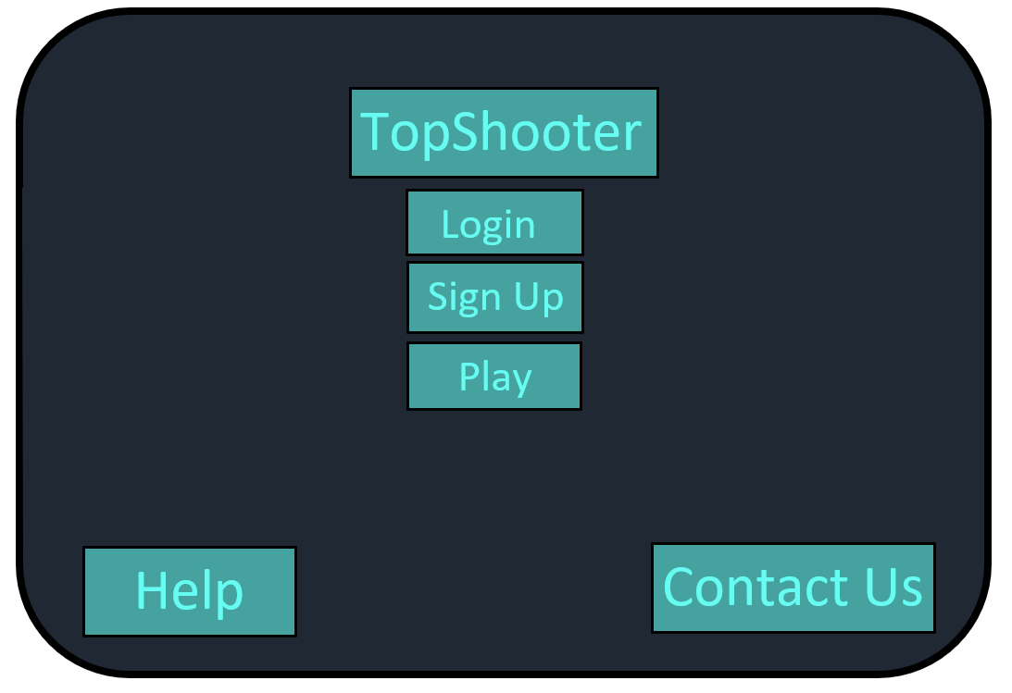This will be the initial screen that the user is greeted to. The background should end up changing to being the background of the actual game. The menu design is a very simple one. It has limited options where the users can log in, sign up, play as a guest then even request help and be directed to a form which they can fill in to contact us.